Instructions for Adjusting the Day Care Status

1. Log into the website at <http://outreach.cs.dal.ca/daycare/wp-login.php>  
   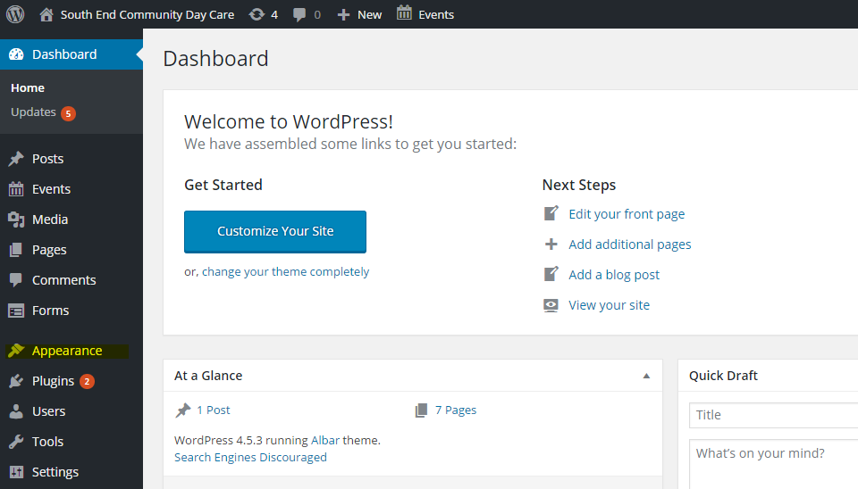
2. Click on Appearance in the Dashboard  
   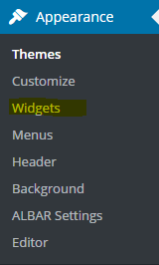
3. Click on “Widgets.
4. You should be able to see the Widgets menu  
   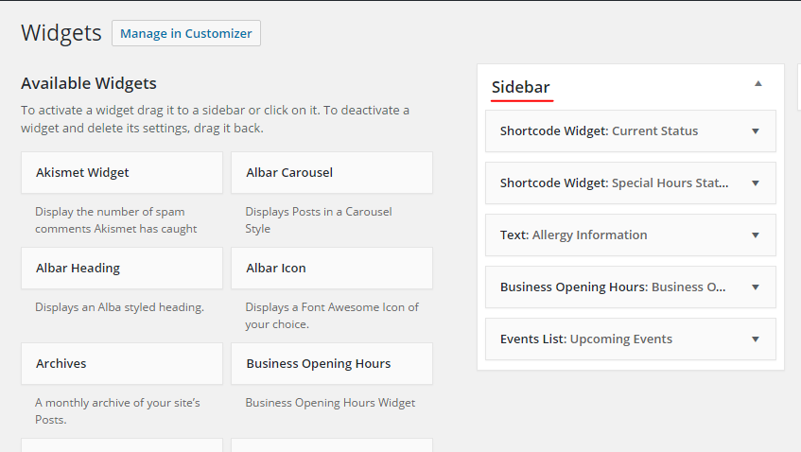
5. The Sidebar section shows all the “Widgets” that are currently displayed in the sidebar of your site. A Widget is a small piece of functionality that will appear in your site.
6. There are two widgets that are used to control the status that is displayed to site visitors :
   1. Shortcode Widget: Current Status  
      This widget displays the status that shows if the daycare is operating under regular business hours.
   2. Shortcode Widget: Special Hours Status  
      This widget is displayed if there is a special closure (such as a snow day), or special hours (like holiday hours).
7. If you click on “Shortcode Widget: Current Hours” you should see the image below:  
   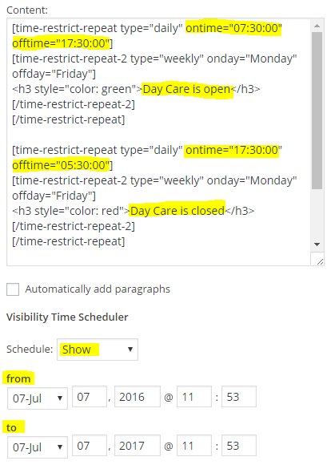  
   The “Content” box contains some special code that controls the status message and causes it to turn from Open to Closed automatically. You can see the highlighted “ontime” is set to 7:30. This means that the message in this block will display at 7:30am. By altering this time you can change the regular open hours of the facility.  
   The highlighted off time is set to 17:30 (5:30pm), by altering this number you can alter the closing hours of the facility. Likewise in the second paragraph, the hours for the closed status are set. **You should not need to change anything in the content box if you have a snow day or a holiday closure. This information should be changed only if the regular business hours of the facility change.**
8. The dropdown “Schedule” controls whether the regular hours display on the homepage or not. If we want to have a special closure like a snow day or a holiday we will simply schedule the regular hours to hide until the closure is over. Choose “Hide” from the dropdown menu, and then choose the interval during which the regular hours status should be displayed. If you are creating a special closure for a snowday, you probably only want to create a one day interval. If you are closing the facility for the holidays, you can schedule the regular hours to be hidden for several days.  
     
   For example, the image below shows what the Current Status schedule might look like during the holidays:  
     
   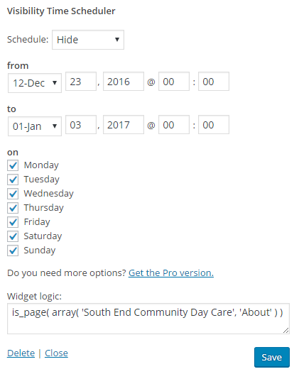  
     
   When you have created the Hiding schedule that you want, click Save
9. Next, you’ll want to create a similar Showing schedule for the Special Hours widget so that the special closure status shows when the regular status is hidden.  
   The image below shows the Special Hours schedule that would correspond with the Regular hours schedule that we set in step 11.  
     
   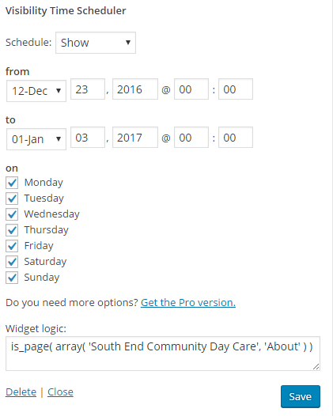  
   Click Save when you’re done.
10. Finally, you might want to update the message of the special. To do this simply replace the highlighted message in the image below and click save:  
      
    